**HIVE IN CLASS – ASSIGNMENT**

|  |  |
| --- | --- |
| **Student Name** | Mazaharuddin Mohammad |
| **Student Number** | N01464978 |
| **Subject Name** | [Big Data 1 - ITE-5200-IRA](https://learn.humber.ca/webapps/blackboard/execute/courseMain?course_id=_187043_1) |
| **Professor Name** | Orren Johnson |

**7)**

**A)**

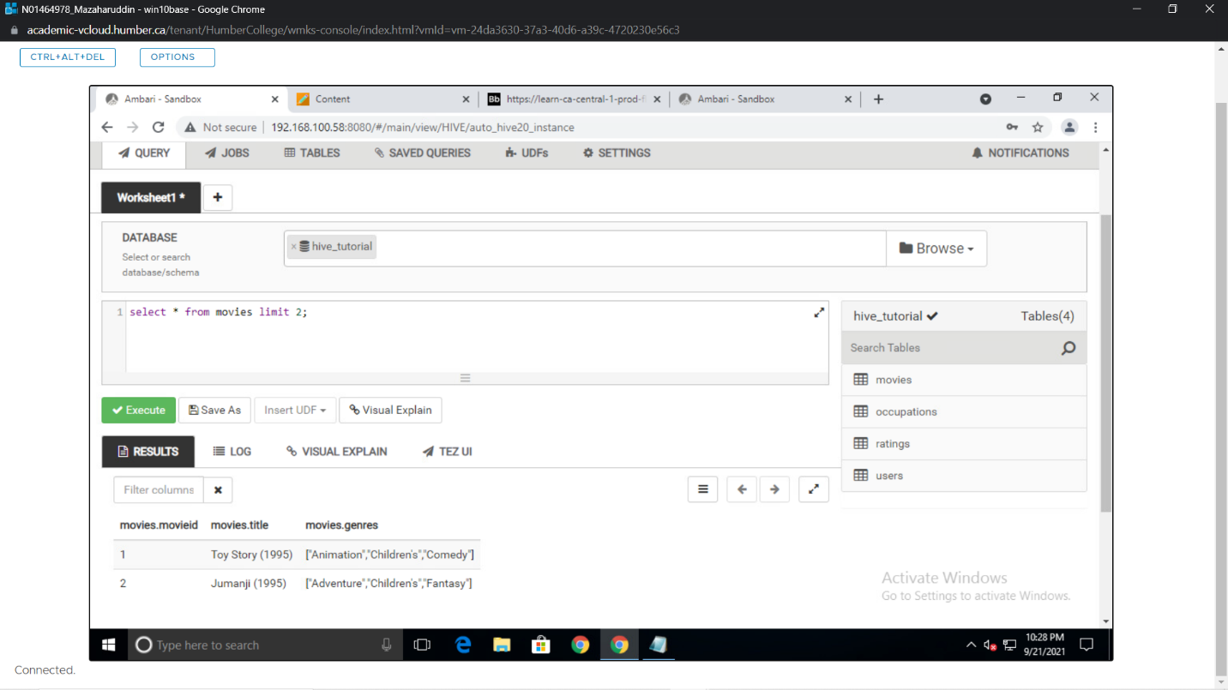

**B)**

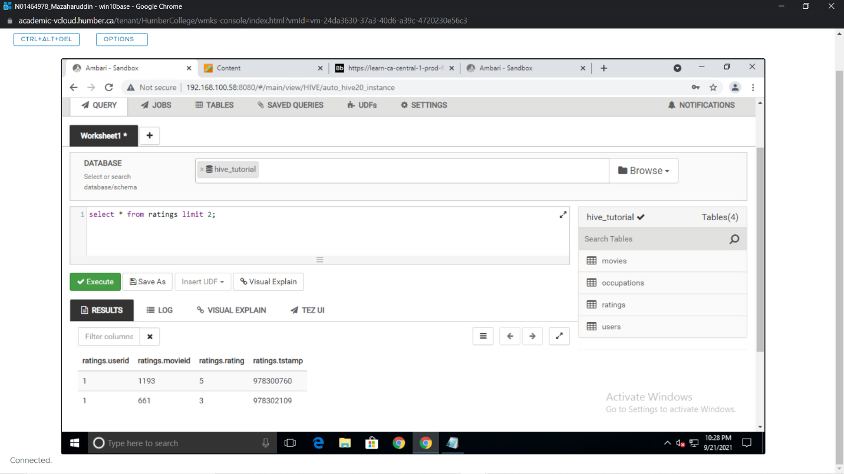

**C)**

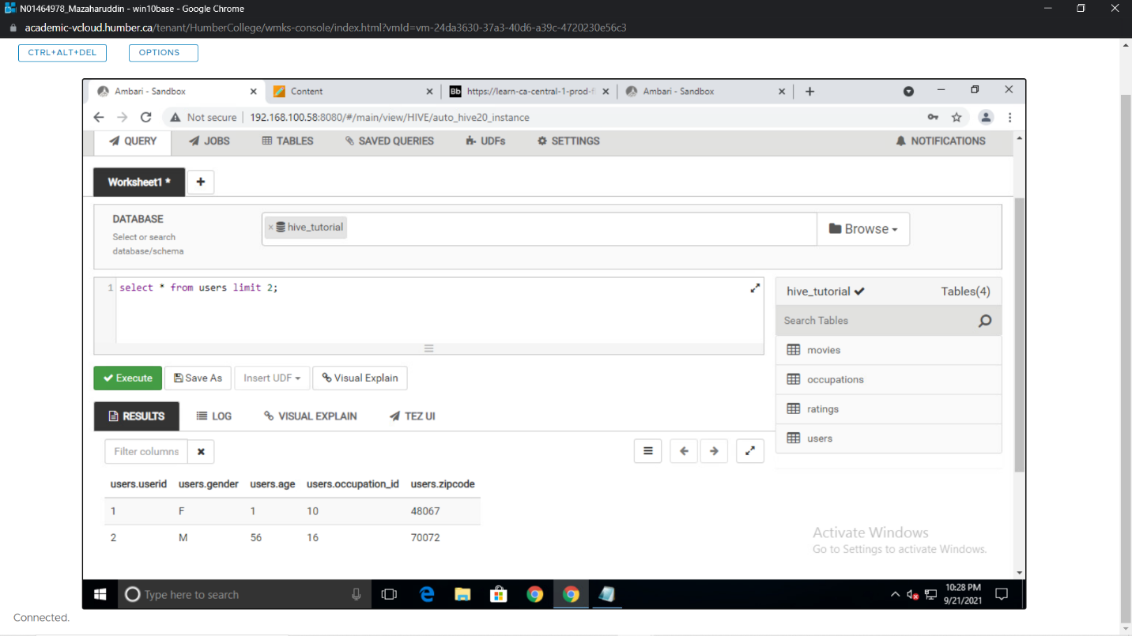

**D)**

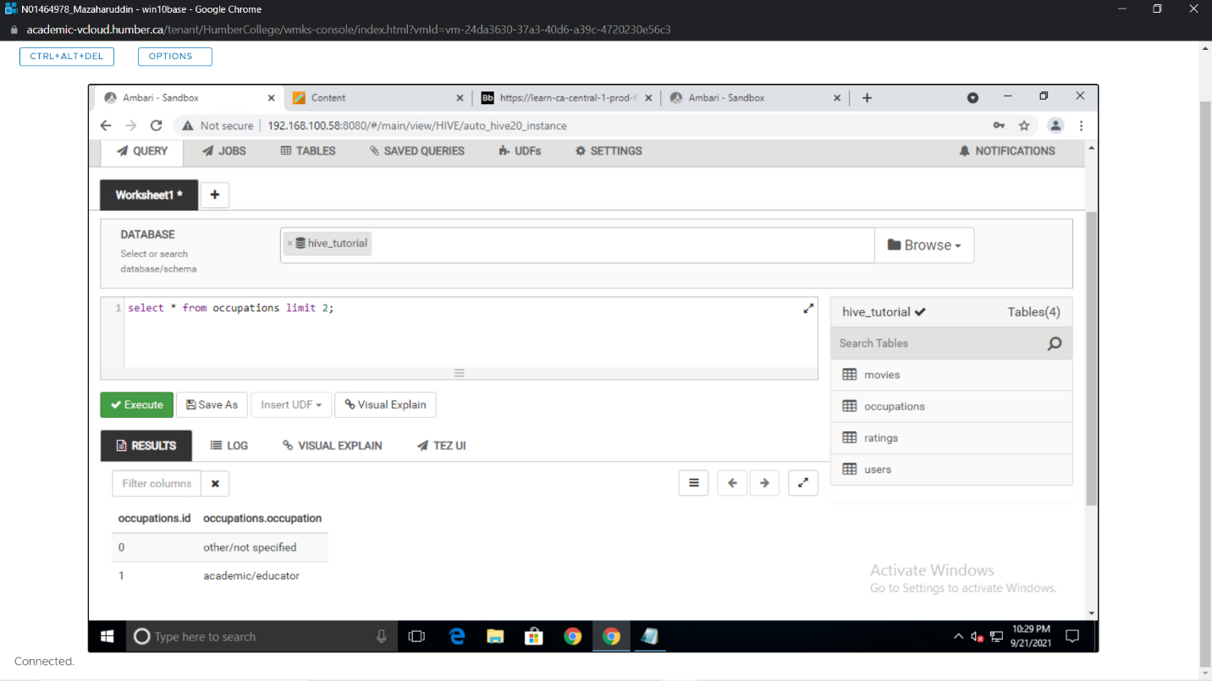

**Use cases – SQL:**

1. **Select users.*,**

**occupations.occupation**

**From users**

**Inner join occupations**

**On users.occupation_id = occupations.id**

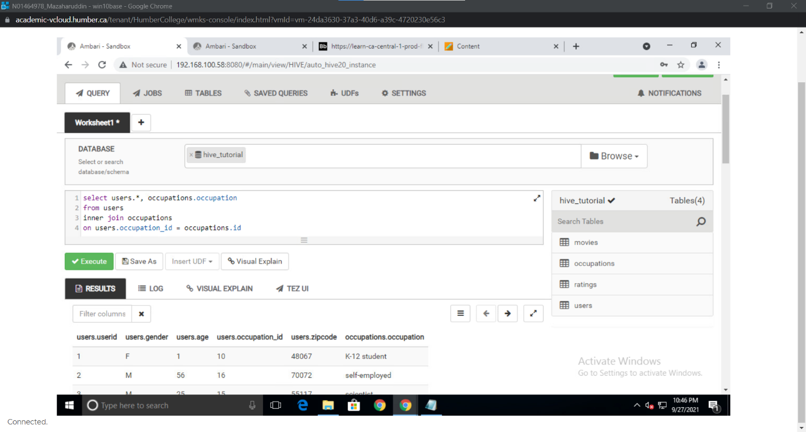

1. **select count(DISTINCT userid) as No_of_users**

**From users**

**Where age < 18**

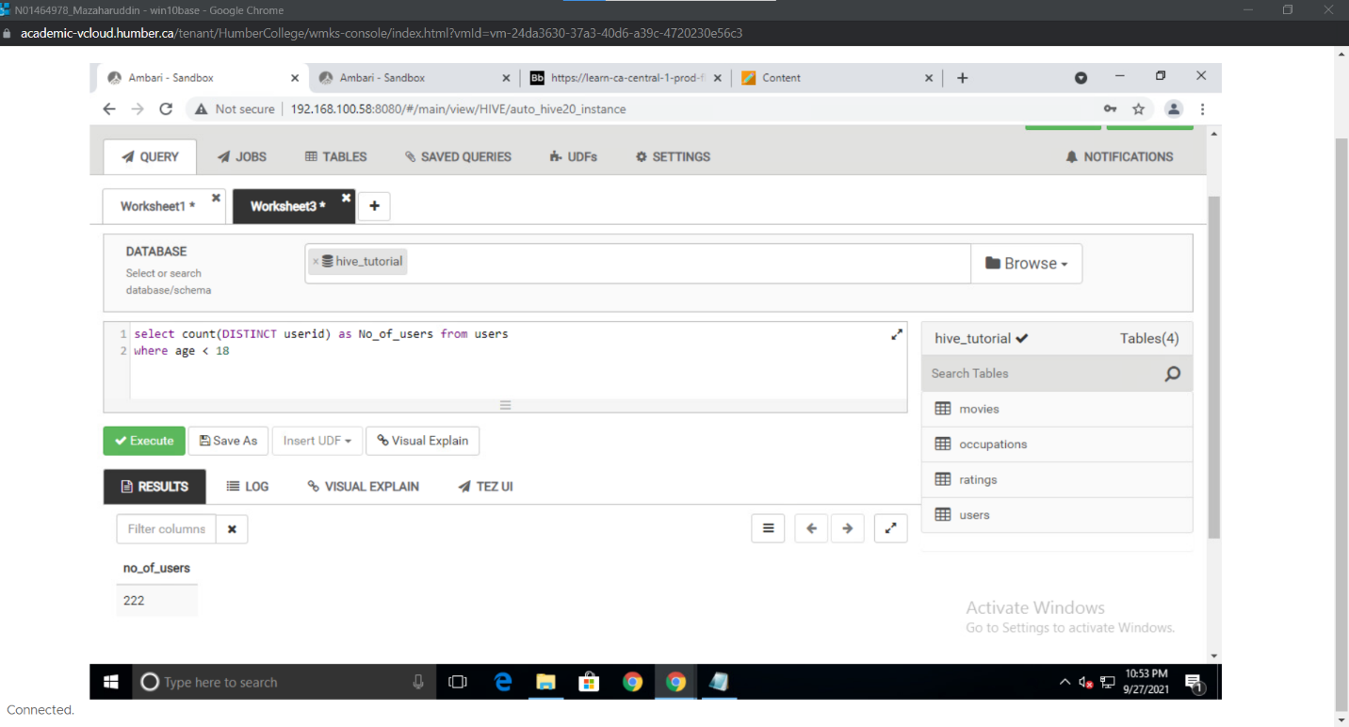

1. **select occupations.occupation,**

**count(users.userid) as No_of_users**

**From occupations**

**Inner join users**

**On users.occupation_id = occupations.id**

**Where users.age > 25**

**Group by occupations.occupation**

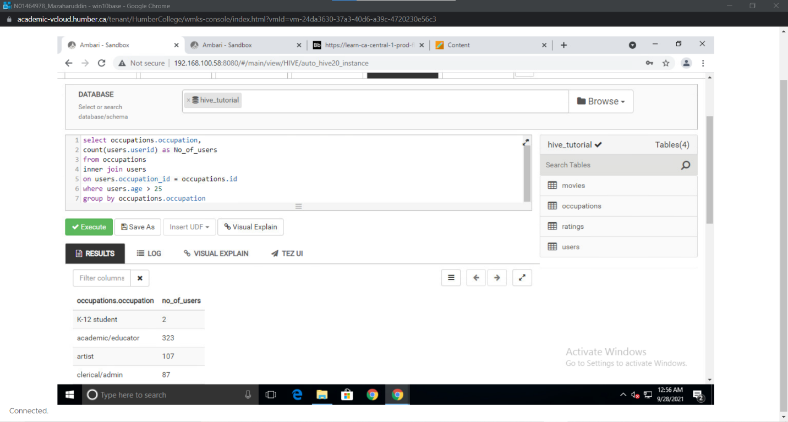

1. **select users.userid,**

**users.age,**

**count(ratings.userid) as total_ratings**

**From users**

**Inner join ratings**

**On users.userid=ratings.userid**

**Group by users.userid, users.age**

**Order by total_ratings desc limit 1**

